Rigging calculation tool validation

Introduction
This document describes the functionality and validation of a rigging calculation tool.
The tool consists of a calculations spreadsheet and a Streamlit app:
- Calculation spreadsheet: Where all calculations are done
- Streamlit app: The calculation spreadsheet can be uploaded here to generate a structured report

Calculation sheet

Instructions
Gives general instructions to user. Not used in calculation or report.

0-Loads
This is sheet gives input to the first page of the report. There shall only be one “0-Loads” sheet and it should not be renamed.
The top section is for general project input, and will be included in the header or title of the report:
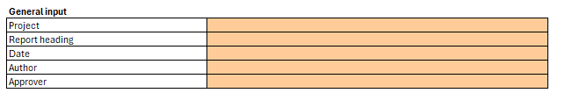
A picture file name can be specified. This will enable the report generator to recognize which picture goes on this page in the report
The static hook load in kN is calculated as:
SHL = (W_lift * y_con + W_rig + W_special) * 9.81
The DAF can then either be directly input or calculated using DNV-ST-N001 Section 16.2.5.5. The DAF calculation cell can be modified, but for simplicity for the user it is set to Offshore 3<SHL<=100t. The DAF calculation cell is only used if no input is given in the DAF direct input cell.
The dynamic hook load is calculated as:
F_hook = SHL * DAF
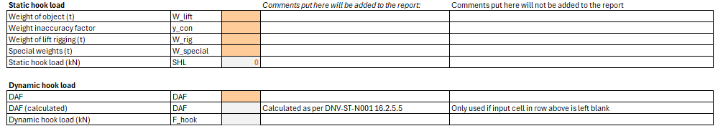
Sling loads can be given either as direct input or calculated based on number of slings, angle, CoG shift factor and skew load factor. The calculated values are only included in the report if the direct input cells are left blank.
Sling loads are calculated as:
F_leg = (F_hook * CoGsf * SKL) / (n_legs * sin(leg_beta))
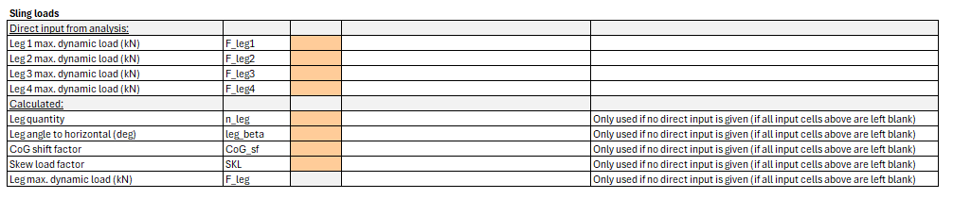
Comments can be added to the report either under “Comments put here will be added to the report or in the comment field at the bottom.
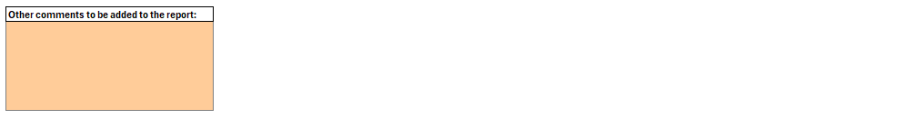

1-SlingRopeWire
This sheet is used for calculation of utilization in slings, ropes, chain, wire etc. This sheet can be renamed and copied to add more items.
The header section gives a description of the item.
A picture file name can be specified. This will enable the report generator to recognize which picture goes on this page in the report
Below, general inputs about the rigging item can be specified.
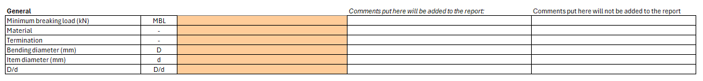
Then, the user inputs the safety factors. The resulting reduction factors are calculated as per DNV-ST-N001 Section 16.4.
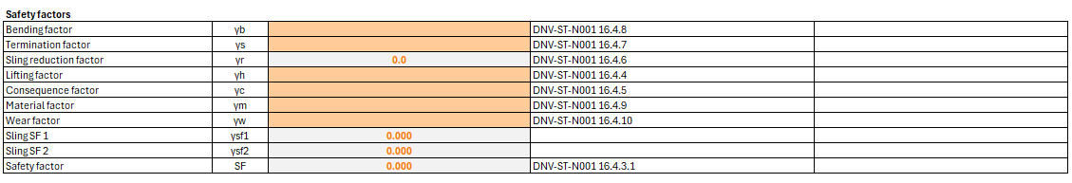
In the loads section, the user can specify which load should be used for this item by selecting the correct load in the drop-down list. This takes the load from the “0-Loads” page. The required MBL is calculated as:
MBL_R = (y_LF * MBL / SF)
The utilization ratio is then calculated as:
UF = F_hook / MBL_R
Comments can be added to the report either under “Comments put here will be added to the report or in the comment field at the bottom.


2-ShacklesHooks
This sheet is used for calculation of utilization in shackles, hooks, masterlinks etc. This sheet can be renamed and copied to add more items.
The header section gives a description of the item.
A picture file name can be specified. This will enable the report generator to recognize which picture goes on this page in the report
Below, general inputs about the rigging item can be specified.
Then the allowable load is calculated from user inputs as per DNV-ST-N001 16.5.2.6:
In the loads section, the user can specify which load should be used for this item by selecting the correct load in the drop-down list. This takes the load from the “0-Loads” page.
The utilization ratio is then calculated as:
UF = F_hook / Allowable load on item
Comments can be added to the report either under “Comments put here will be added to the report or in the comment field at the bottom.


Streamlit app

Excel template download
There is a button to download the Excel template described above.

Upload file
The user can upload either the calculation sheet only (xlsx), or a zip file containing both the calculation files and any image files.
The input is read directly from specified cells in the spreadsheet, hence the cells from which the input is taken from can not be changed by the user.

Images
A list of all sections in the report will appear. If the user has specified any image file names and uploaded them in a zip, they will appear in the list. The list can be left unchanged, or edited in the app to remove, replace or add images. Only one image per section is allowed.

Summary table
This section summarizes the utilization of each item in the calculations. This table will also be added to the last page of the pdf report.

Generate report
The user can click “Generate PDF” to generate a report of the calculations. It can by downloaded by clicking “Download PDF”.

Validation

Input validation
The calculation spreadsheet does not have any restrictions on user input. All input validation is done on import to the Streamlit app.
Below is a list of all variables that are imported from the Excel sheet, and how the input is validated:

Calculation validation
To validate the calculations, an existing approved rigging calculation was used. The validation was considered passed if the result produced was identical to the report, and the report was of comparable quality.

